3. https://github.com/ghosthunter09/inf1103-labs
4. 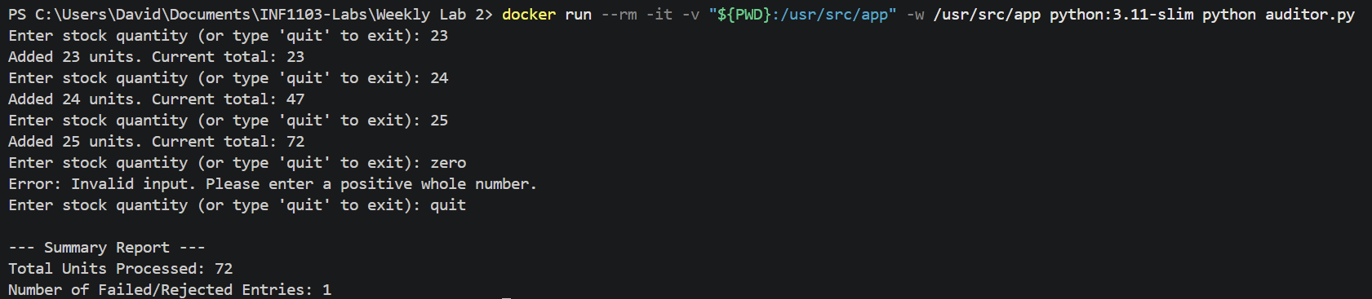
5. 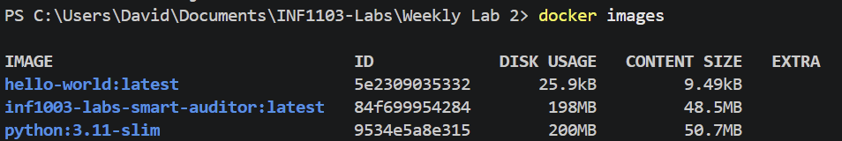
6.
